I have tested the user registration , login using the postman API tester. In the screenshot below represents the registration part. Here, we can see that we have successfully registered.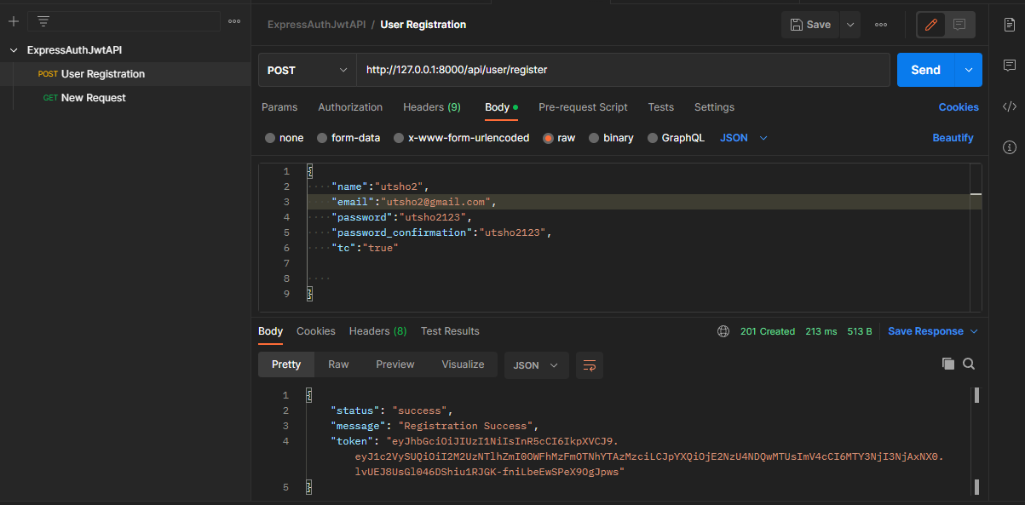

Here’s the screenshot of the database.

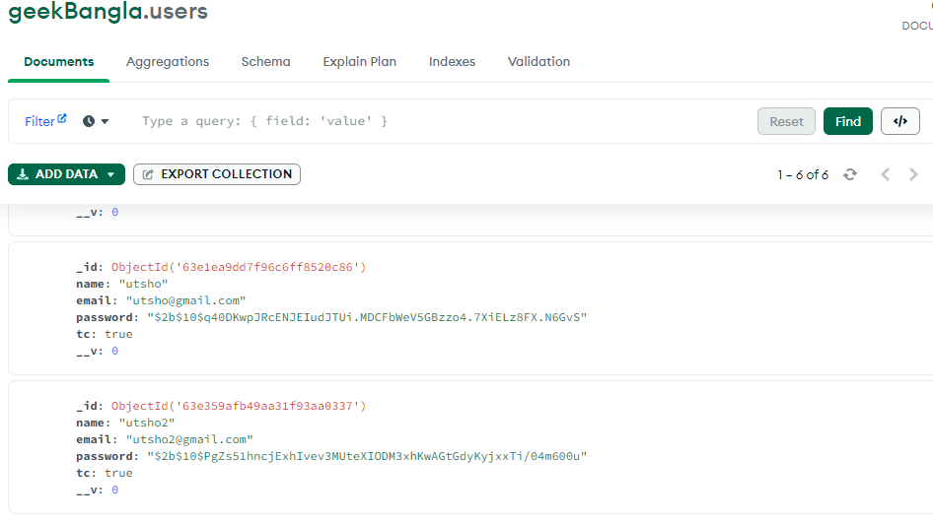

As you can see, the password is hashed. I have used the bcrypt library to hash the password. Here’s the code snippet of the hash function in the Usercontroller.js

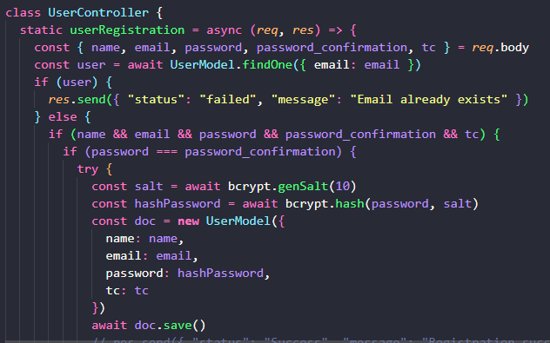

Here’s the part where we can get prompts for the registration process.

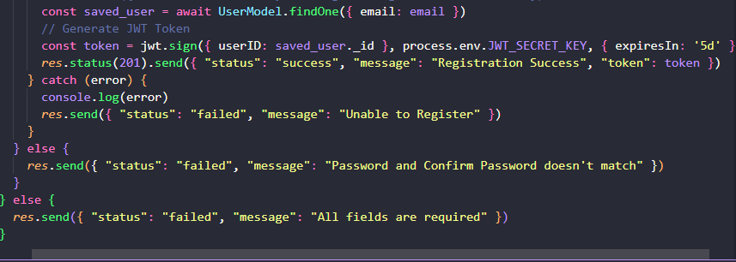

User login function

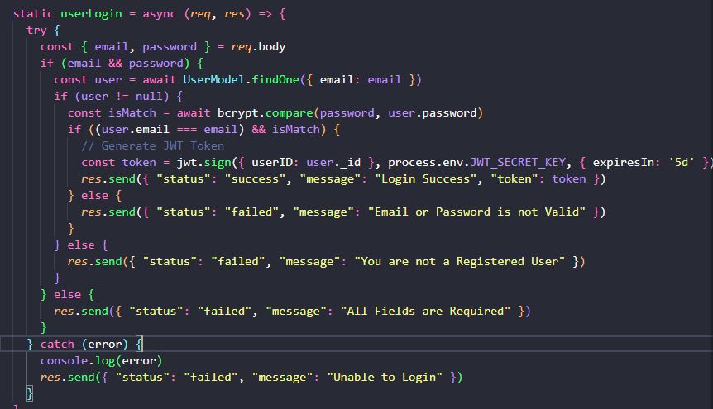

Change user password part is down below

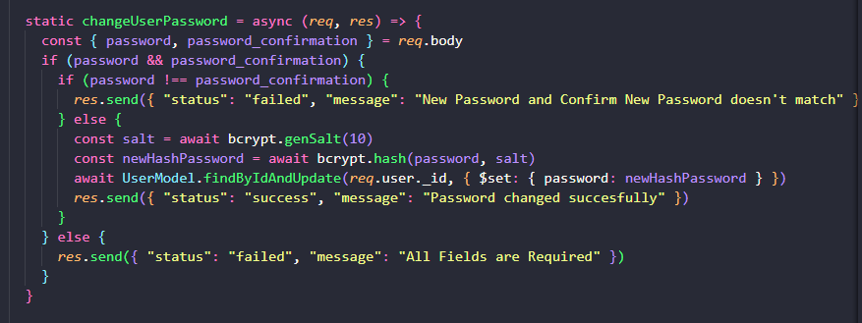

User password reset function

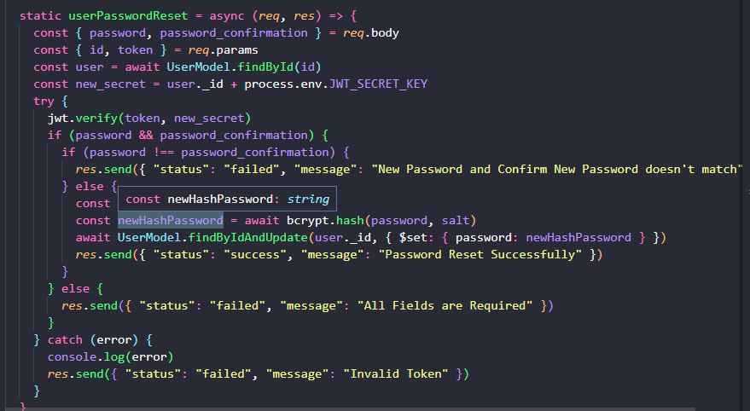

We can also reset password using nodemailer

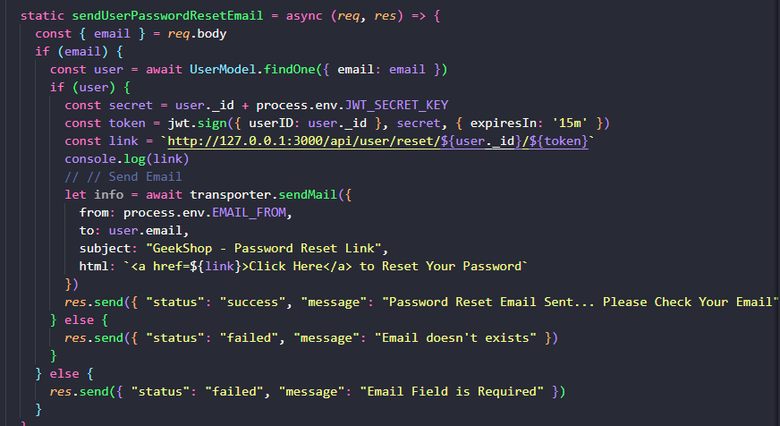

Here’s the schema for database

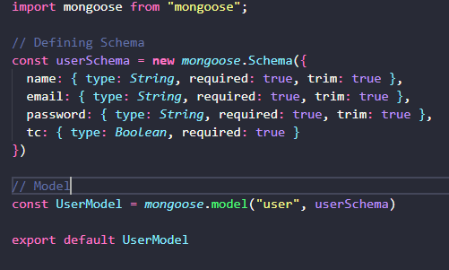

This is for the password reset emailconfig.js. There are some additional test needed .

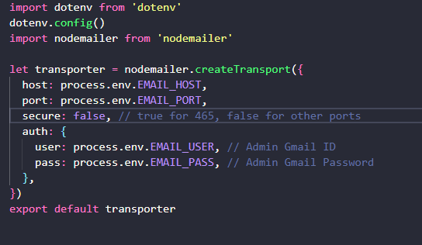

Here’s the config for the database address, secret key and nodemailer in the .env file

